Commands used:

OpenSSL:
- Use the OpenSSL tool to generate RSA private key (key length 2048 bits):
- openssl genrsa -out private_key.pem 2048
- Based on private key, generate public.key:
- openssl rsa -in private_key.pem -outform PEM -pubout -out public_key.pem
- Sign the file with the following commands:
- openssl dgst -sha256 -sign private_key.pem -out encrypted_hash.sha256 data.txt
- To verify the signature, run the following command:
- openssl dgst -sha256 -verify public_key.pem -signature encrypted_hash data.txt
- OpenSSL documentation is available here: https://www.openssl.org/docs/

OpenPGP:
- Generate key pair using GPG tool:
- gpg --expert --full-gen-key
- Before generating the key you must complete the fields (key length, elliptic curve, …):
- Some useful commands are:
- List public keys: > gpg --list-keys
- List private keys: > gpg --list-secret-keys
- Export a public key:
  - ASCII > gpg --output <file name> --export --armour <email_address/key ID>
  - Binary > gpg --export --output <file name> <email_address/key ID>
- Export a private key: > gpg --export-secret-keys -a <file name> <email address>
- Importuj klucz: > gpg –-import <file name>
- Sign a file: > gpg --sign <file name>
- Sign a file with a selected key: > gpg --sign -u <key_id> <file name>
- Verify a signature: > gpg --verify <file name>.gpg
- Sign an imported key: > gpg --sign-key
- Encrypt a file with gpg: > gpg --encrypt –-recipient <email address/key ID> --output <output file> <input file>
- Other useful operations of gpg:
  - > gpg –-fingerprint
  - > gpg -–edit-key

Application of modern cryptography:

Generate a set of keys using OpenSSL (RSA) and OpenPGP (ECC and RSA):
OpenSSL (RSA): To generate the private key: > openssl genrsa -out A_OpenSSL_private_key.pem 2048
To get the public key: > openssl rsa -in A_OpenSSL_private_key.pem -outform PEM -pubout -out A_OpenSSL_public_key.pem
OpenPGP (ECC): > gpg --expert --full-gen-key
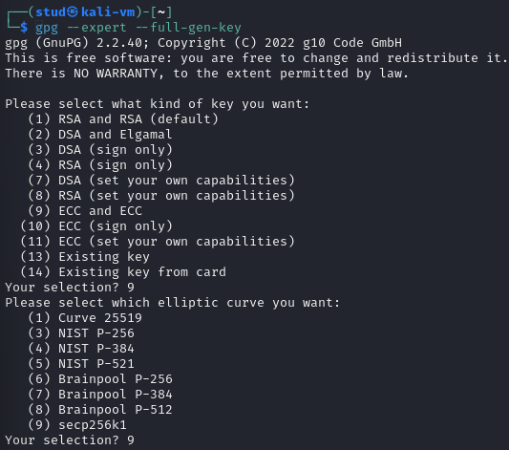
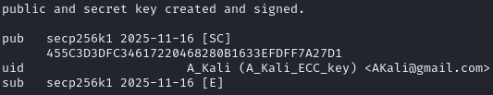
" A_Kali (A_Kali_ECC_key) <AKali@gmail.com>" -> Password: 123456789
OpenPGP (RSA): > gpg --expert --full-gen-key
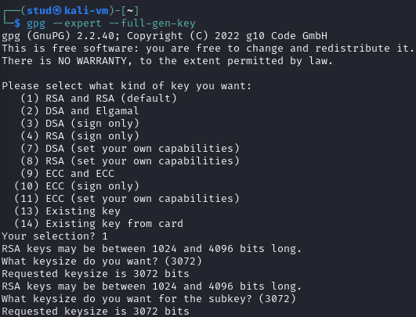
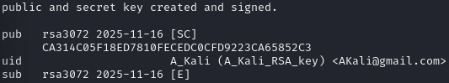
" A_Kali (A_Kali_RSA_key) <AKali@gmail.com>" -> Password: 123456789

List the keys generated: gpg --list-keys
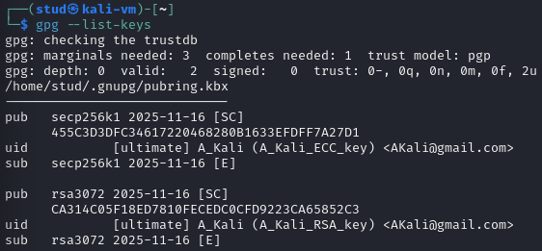

Export a public key from GPG (ACSII format):
By > gpg --output A_Kali_ECC_public_key --export --armour 455C3D3DFC34617220468280B1633EFDFF7A27D1
and gpg --output A_Kali_RSA_public_key --export --armour CA314C05F18ED7810FECEDC0CFD9223CA65852C3:
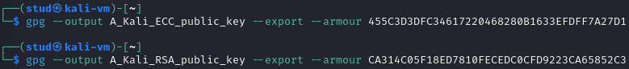

Transfer your public key (OpenSSL and OpenPGP) to another machine/user account:
Transferring the files as: sftp student@192.168.144.5 (Where 192.168.144.5 is the ubuntu machine: ip a)
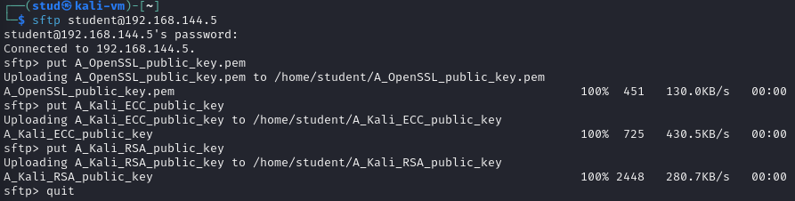
Transferred the files: put A_OpenSSL_public_key.pem / put A_Kali_ECC_public_key / put A_Kali_RSA_public_key
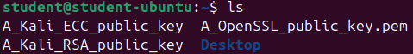
So now all the public keys are in the ubuntu machine.

For OpenPGP, a public key should be imported and signed with a local private key. Verify a fingerprint of a certificate on both machines/ user accounts:
We label the machines -> A (key owner - Kali) and B (signer - Ubuntu):
B imports A’s public keys: > gpg --import A_Kali_ECC_public_key
and > gpg –import A_Kali_RSA_public_key
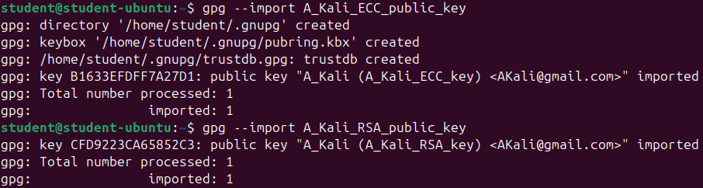
The fingerprint is calculated by hashing 0x99 | 2 bytes of the public key length | public key.
Check A’s fingerprints and B’s fingerprints and compare if they are the same: > gpg --fingerprint
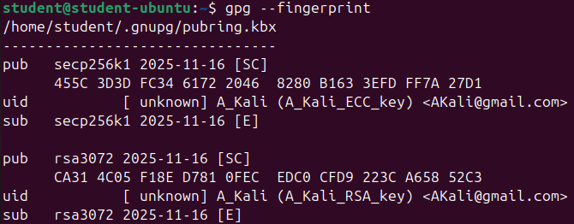
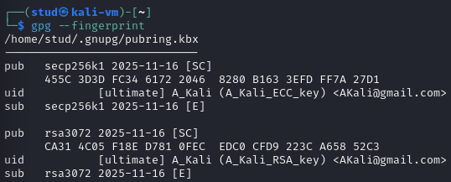
The fingerprint for A’s ECC is: 455C 3D3D FC34 6172 2046 8280 B163 3EFD FF7A 27D1
The fingerprint for A’s RSA is: CA31 4C05 F18E D781 0FEC EDC0 CFD9 223C A658 52C3
Machine B needs to create a private key for signing A’s keys: > gpg --expert --full-gen-key
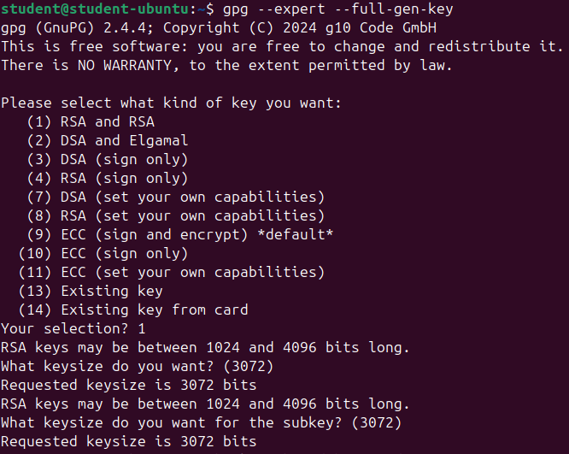
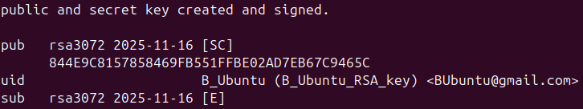
"B_Ubuntu (B_Ubuntu_RSA_key) < BUbuntu@gmail.com>" -> Password: 123456789

To sign the key: A_Kali (A_Kali_ECC_key) <AKali@gmail.com> with the key: B_Ubuntu (B_Ubuntu_RSA_key) BUbuntu@gmail.com
You need to check their keyID by: gpg --list-keys
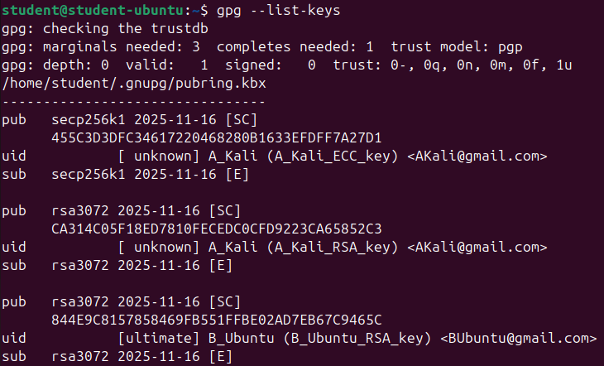
You write the command: > gpg --local-user 844E9C8157858469FB551FFBE02AD7EB67C9465C --sign-key 455C3D3DFC34617220468280B1633EFDFF7A27D1
We sign the public keys as we are sure that the keys are fine and have not been altered by anyone.
> gpg --local-user <BKey> --sign-key <Akey>
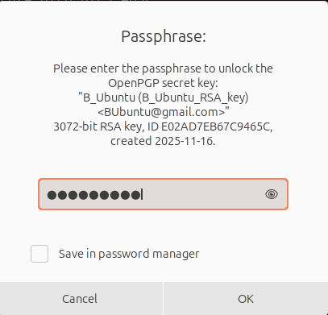
Once both A keys are signed, check with: > gpg --check-sigs
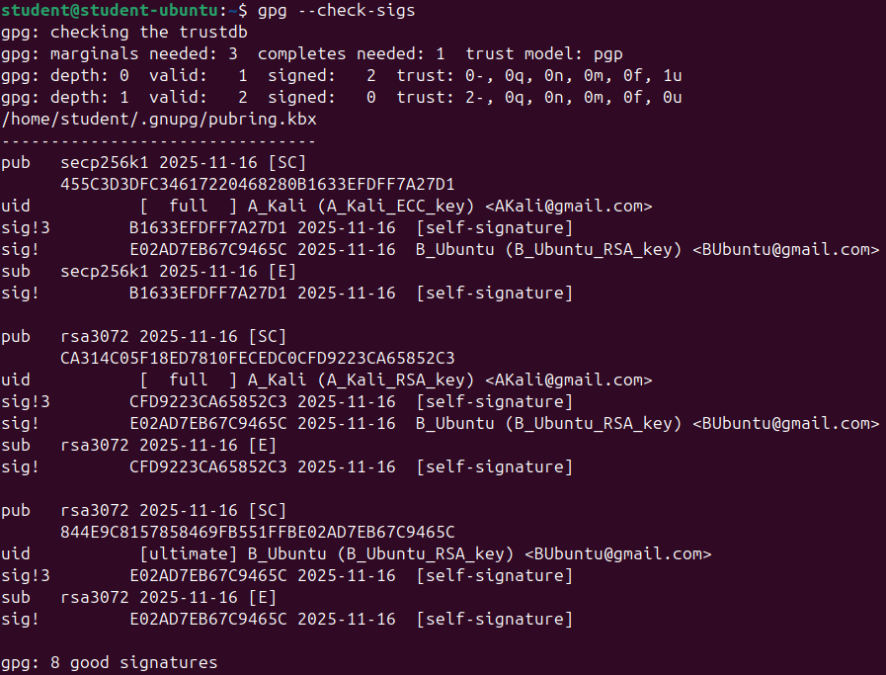

Create a text file and sign it using both methods:
Once created the file: > nano importantData.txt
And fill it with important text.
Sign it with OpenSSL: > openssl dgst -sha256 -sign <private_key.pem> -out <signature_file> <input_file>
So: > openssl dgst -sha256 -sign A_OpenSSL_private_key.pem -out importantData.txt.opensslSig importantData.txt

And sign with gpg: > gpg --sign -u <GPG_KEY_ID> --output <signedNameFile> importantData.txt
So: > gpg --sign -u 455C3D3DFC34617220468280B1633EFDFF7A27D1 --output importantData.txt.ECCSig importantData.txt
And: > gpg --sign -u CA314C05F18ED7810FECEDC0CFD9223CA65852C3 --output importantData.txt.RSASig importantData.txt
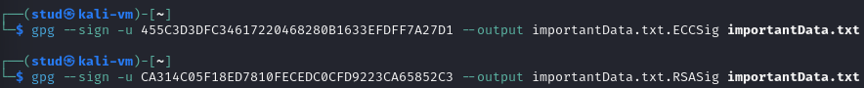

Transfer your file and signatures to another machine/user account and verify the signatures:
After sending the files through sftp as in question 2.3.
To check OpenSSL: > openssl dgst -sha256 -verify <public_key> -signature <signature_file> <data_file>
To check gpg: gpg --verify <sigFile> / To check the contents: gpg --decrypt <sigFile>
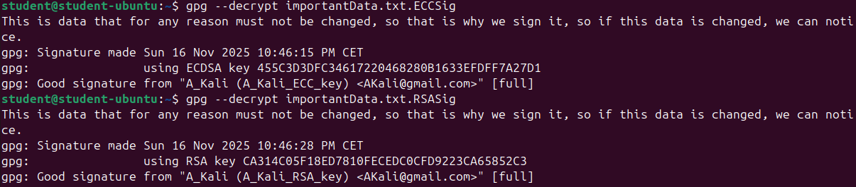

After the signature has been successfully verified, modify the content of the original document and verify the digital signature again:
Check OpenSSL modified:
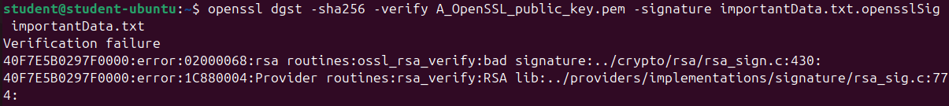
Check gpg:
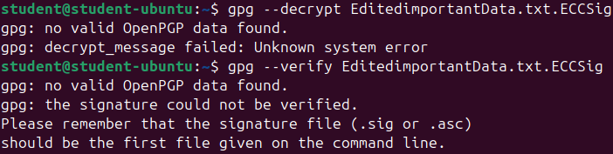

Only for OpenPGP. Encrypt the file using a public key and then decrypt the encrypted file. Afterward, change one character in the encrypted file and try to decrypt it again:
We encrypt a NormalFile.txt in machine B, and transfer it to machine A:
> gpg --encrypt --recipient keyID --output FileEncryptedName File
And to decrypt it: > gpg --output DecryptedFile.txt --decrypt EncryptedFile.txt
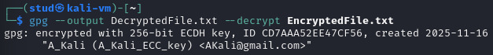
If we change a character in the encrypted file depending on the position we get:
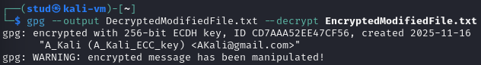
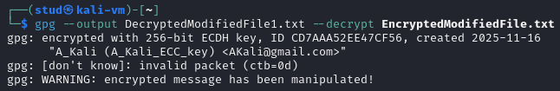
So now we are sure if the file is modified or not.

Is it possible to generate only one of the key pairs for asymmetric algorithms (e.g. private key)? Would this make sense?
Yes, you can generate just the private key (the public key is derivable from it), but it’s of limited practical use unless you plan to export the public key later or keep the private key locked in an HSM. Never share private keys.

What form does the GPG key have? How does a PEM key differ from an Open-PGP key?
GPG / OpenPGP: keys are OpenPGP packets (key material + user-IDs + signatures/subkeys), often ASCII-armored (-----BEGIN PGP PUBLIC KEY BLOCK-----).
PEM: Base64/PEM-wrapped ASN.1/DER structures (PKCS#1/PKCS#8/X.509) holding a single key or certificate.
Main differences: internal format/metadata, trust model (web-of-trust vs PKI), and fingerprint calculation.

Is the exchange of private keys justified?
Generally, no, private keys must remain secret. Only justified for secure, audited actions (key migration/backup, escrow, or threshold schemes) using encrypted channels, HSMs, or split-secret techniques.

What is the fingerprint?
A fingerprint is a short cryptographic hash of a key’s canonical representation used as a stable, human-checkable identifier to detect swapped or altered keys.
The fingerprint is calculated by hashing 0x99 | 2 bytes of the public key length | public key.

Describe what has changed and why in task 7?
You changed the signed document’s bytes; because a signature covers the exact data, verification now fails so integrity is broken.

Did you succeed in changing one character in an encrypted file and decrypt the encrypted text? Justify your answer. (Task 8):
No, altering one character in ciphertext will (with modern OpenPGP’s MDC/AEAD) cause decryption to fail or the integrity check to trigger; you won’t get the original plaintext.

What is the difference in the signature (OpenPGP) for ECC and RSA algorithms?
RSA signs with modular-exponent math (large integers); ECC uses elliptic-curve schemes (ECDSA/EdDSA). ECC gives smaller keys/signatures and comparable security; OpenPGP stores the algorithm ID, but user-level verification is the same.

Can a message be signed with a public key? If so, what could the consequences be?
No, signing requires the private key. “Signing with a public key” is impossible in any meaningful sense; if it were possible the signature would prove nothing (anyone could create it), so authenticity would be lost.

PKI - key generation in X.509 standard -> Build CA:

Change the vars after cp them: > nano vars
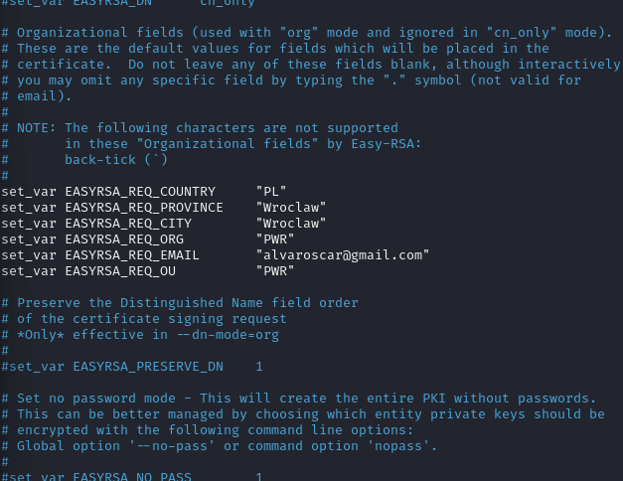

Generation of the keys: > ./easyrsa build-ca nopass
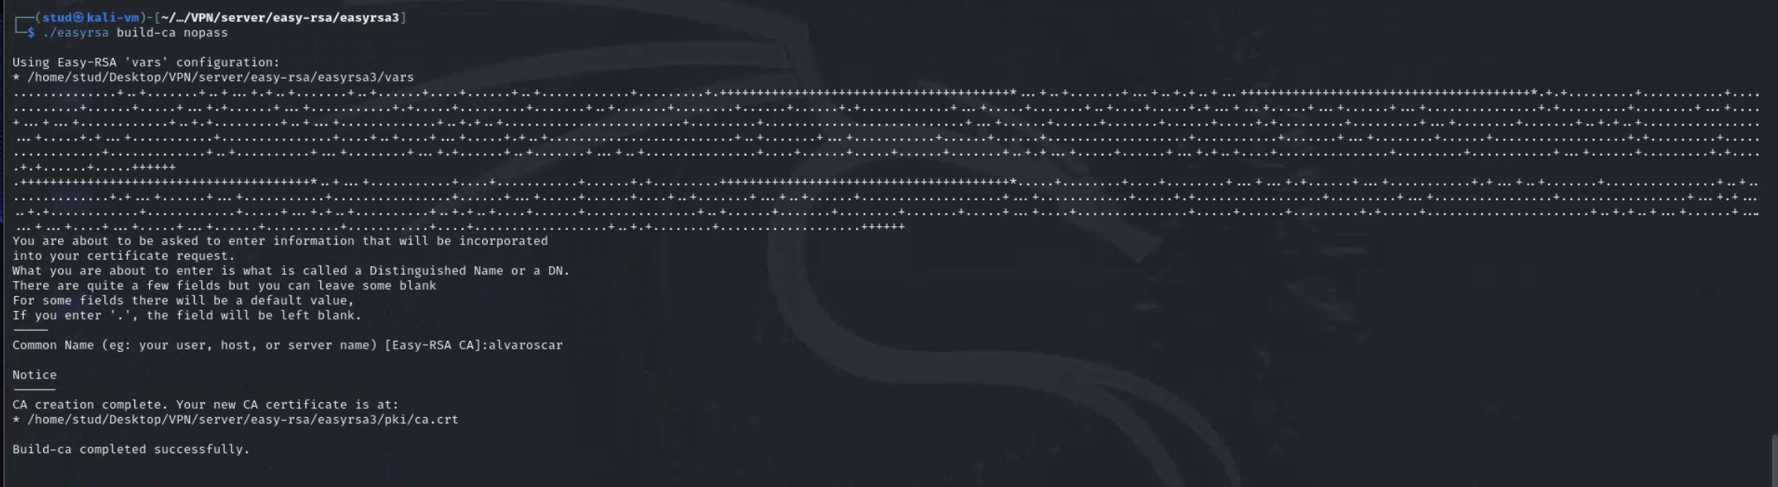

Generate the server and client certificates:

Run the command to generate a server private key (server.key) and a certificate signing request - CSR (server.req):
./easyrsa gen-req server nopass
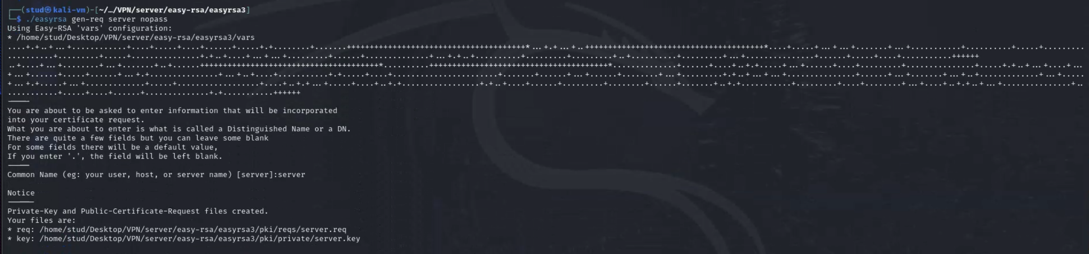

Sign a server request using CA, it generates server.crt:
./easyrsa sign-req server server


Run the command to generate a client private key (client1.key) and a certificate signing request (client1.req):
./easyrsa gen-req client1 nopass:
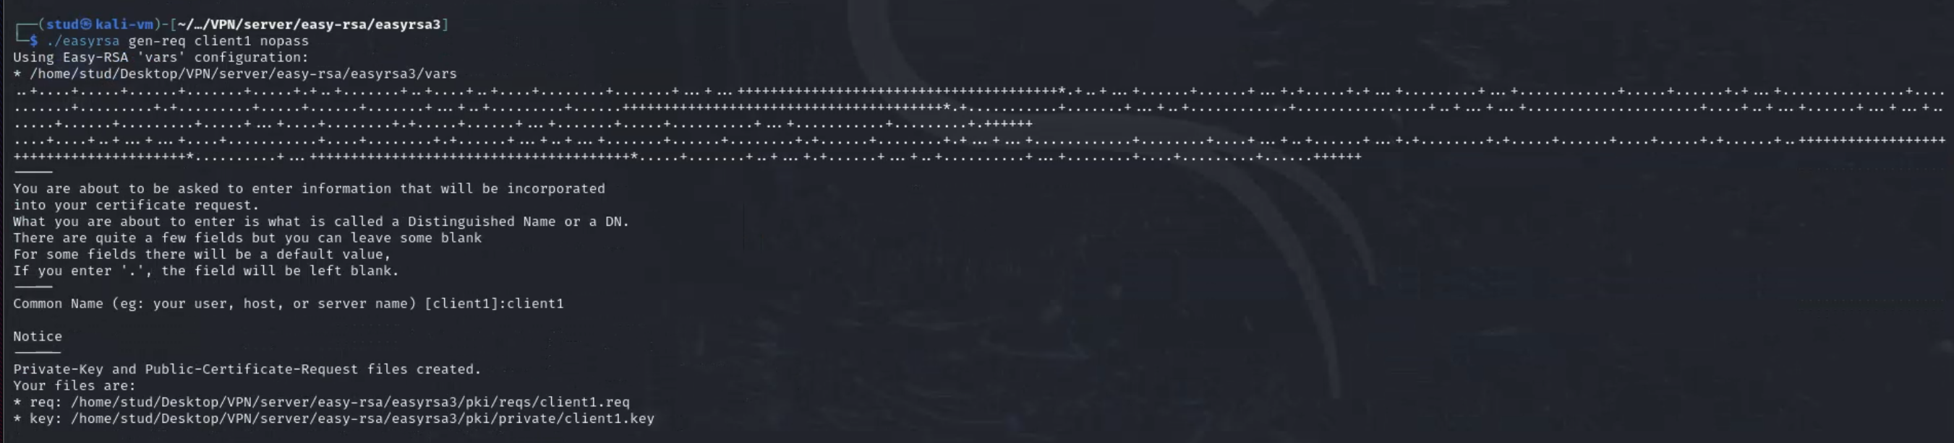

Sign a client signing request using CA, it generates client1.crt:
./easyrsa sign-req client client1
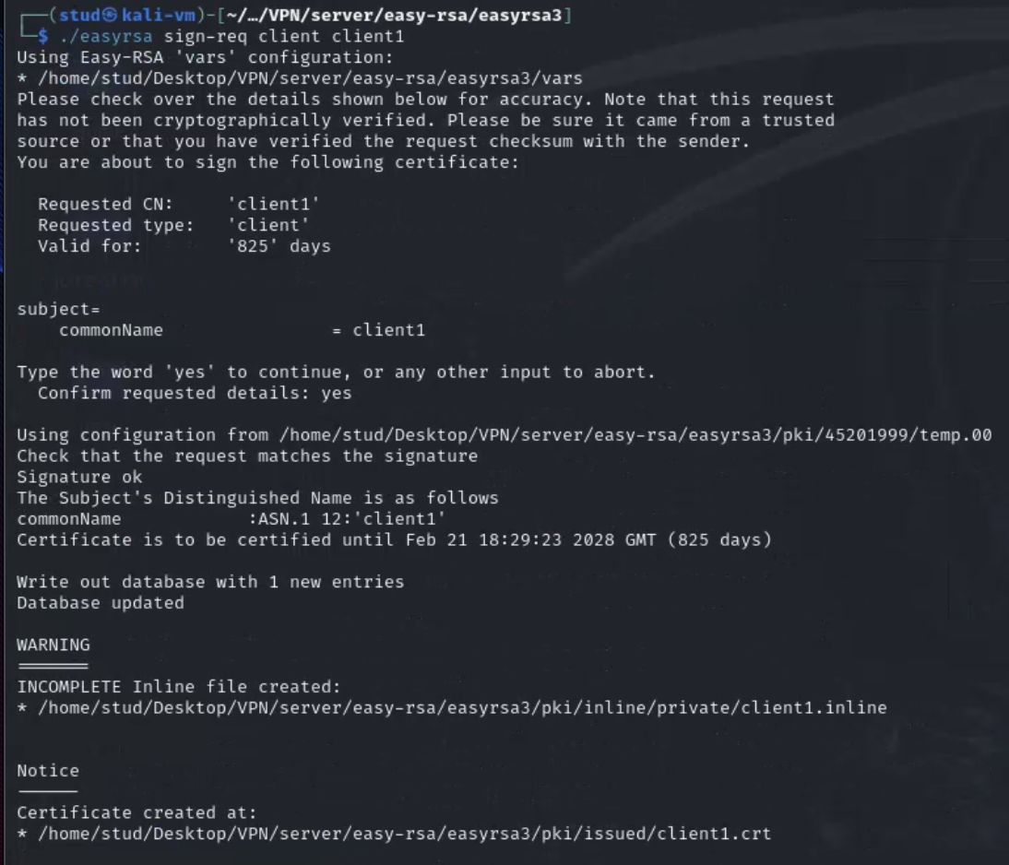

Generate Diffie-Hellman key (dh.pem) which is used to exchange keys:
./easyrsa gen-dh
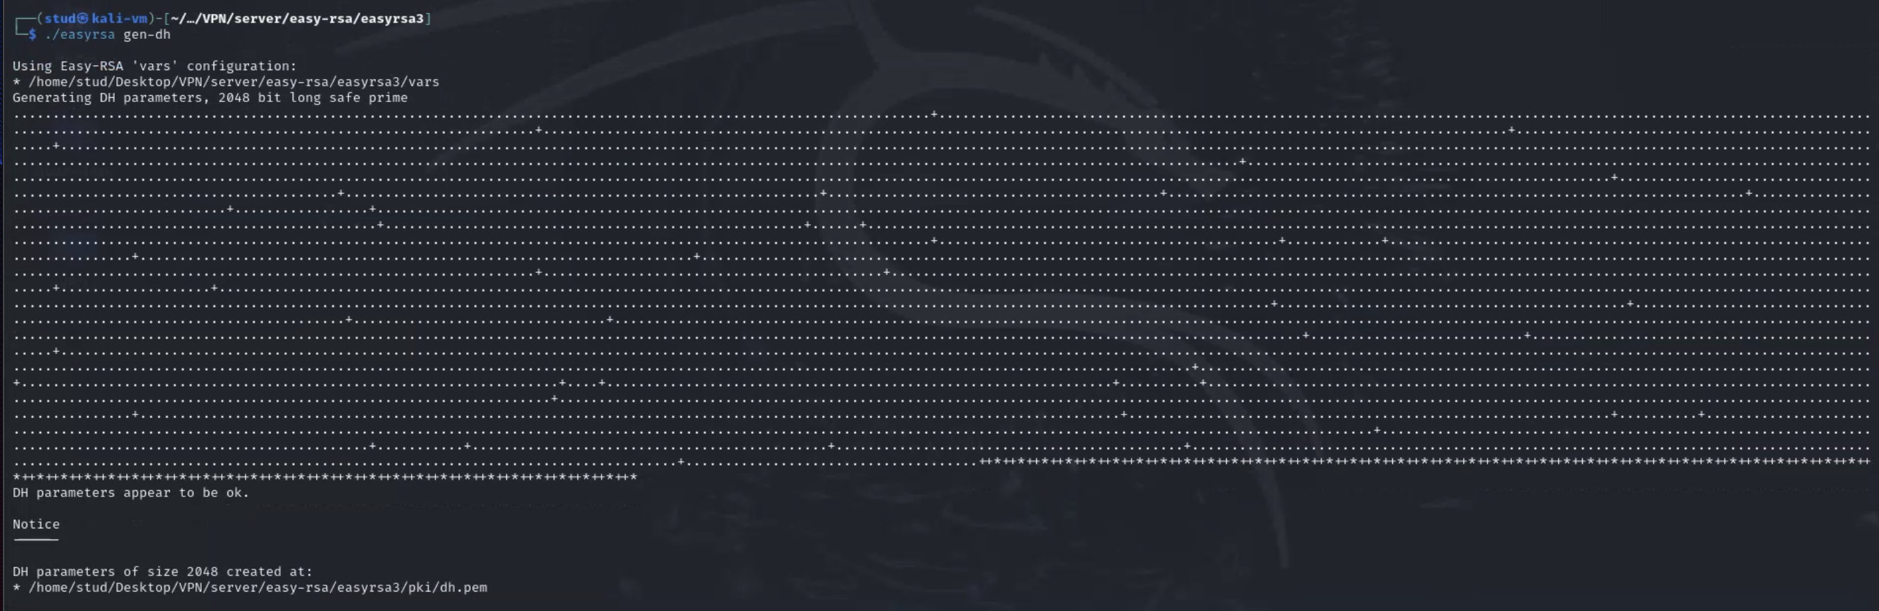

Generate an HMAC signature (ta.key) to strengthen the server’s TLS integrity verification capabilities:
openvpn --genkey --secret ta.key

What is the signature algorithm used?
The signature algorithm used in the certificate is sha256 with RSA Encryption, which means the certificate was signed using RSA and the SHA-256 hashing algorithm.

What is the public key algorithm used?
The public key algorithm used is RSA Encryption (typically with a 2048-bit RSA key).

What version of the X.509 standard has been used to generate a certificate?
Certificates generated by EasyRSA and OpenSSL use X.509 version 3.
This is the most modern version, and it allows the inclusion of extensions such as SAN, Key Usage, etc.

What else can be read from the server/client certificate?
X.509 certificates contain much more information than just the public key. In addition to the signature and public key algorithms, a certificate also includes the issuer (the CA that signed it), the subject (identity of the server or client), the validity period, the serial number, fingerprints, and several X.509 v3 extensions such as Key Usage, Extended Key Usage, Basic Constraints, and identifiers for both the subject and the issuer. These fields define how the certificate can be used and help establish trust in a PKI system.

